**ADK (Python Programming) ROLL NO : 01**

**Aim**: Write the program for the following: (by using control statements and control structure)

(C). Write a program to generate the Fibonacci series.

**Theory: -**

**Practical Implementation:-**

**Code:-**

**# program tp display the fibonacci sequence up to n-th term where n is provided**

**# change this value for a different result**

**nterms = 10**

**# uncomment to take input from the user**

**# nterms = int(input("how many terms?"))**

**# first two terms**

**n1=0**

**n2=1**

**count=2**

**# check if the number of terms is valid**

**if nterms<=0:**

**print("please enter a positive integer:")**

**elif nterms==1:**

**print("fibonnaci sequence upto",nterms,":")**

**print(n1)**

**else:**

**print("fibonnaci sequence upto",nterms,":")**

**print(n1,",",n2,',')**

**while count < nterms:**

**nth = n1+n2**

**print (nth, ' , ')**

**# update values**

**n1 = n2**

**n2 = nth**

**count += 1**

**OUTPUT:**

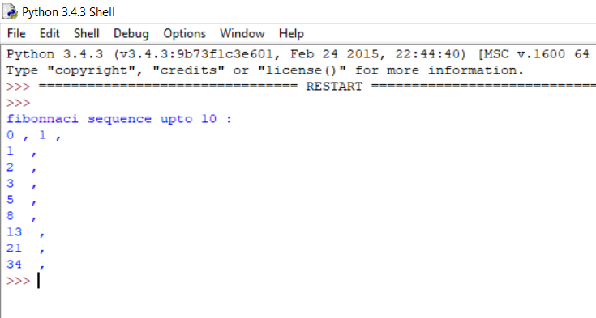

**Conclusion:**